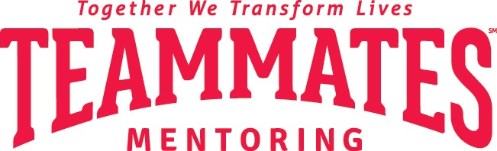
Media Contact:
Hannah Miller
hannah@teammates.org
402-390-8326

TeamMates shines a light on strengths-based mentoring during National Mentoring Month
(Community) — TeamMates Mentoring Program’s coordinators and staff are saying thank you to mentors for simply being there for students in (community).
January 1 marks the start of National Mentoring Month. Nationwide, programs are honoring mentors for their service and the impact they’re making on youth. During the month of January, TeamMates’ National Office is asking the public to “Share Your Shine” by strengths-spotting someone. An example of this would be to send a postcard to a friend, family member, or mentor saying “I see you shine by the way you….”. The goal is to spread gratitude across TeamMates’ 5 states and to show the impact of spotting someone’s strengths.
According to the Gallup student poll, engaged students are 4.5X more likely to be hopeful about their future than their disengaged peers. TeamMates mentees are proven to have higher levels of engagement and 81% say they know their strengths and talents. This is why TeamMates added “Strengths-based” to its Core Values in 2022.
(Information about chapter’s specific NMM activities)
“We are grateful for every TeamMates mentor,” TeamMates Chief Executive Officer DeMoine Adams explained. “Every TeamMates mentor I speak with talks about how mentoring has been an incredibly positive experience for them. I hope more caring adults will join us so they too can experience the positive impact of mentoring.”

The mission of the TeamMates Mentoring Program is to impact the world by inspiring students to reach their full potential through mentoring. TeamMates serves more than 10,000 youth in 180+ communities across Nebraska, Wyoming, Kansas, South Dakota, and Iowa. Mentors meet with their mentees one-on-one in school, once a week, during the academic year or in the college program once a month.
To schedule an interview about the TeamMates Mentoring Program, please contact Hannah Miller at Hannah@teammates.org or (program coordinator and contact information).

###

